# **USER EXPERIENCE (UX) DESIGN WORD DOCUMENT**

**I/ About the Web Project:**

1/ Introduction:

* This webpages was made for the project 2 of SIT120: Add Design and Web App.
* The aim of the website : Education – provide a funny and friendly environment for children to learn.
* This document will give an overall description of the Web Project.

2/ Target Audience:

* Primary audience: Pre-school Children ( 3- 6 aged)
* Secondary audience: Parent of those kids

3/ Scope:

* Provide friendly and attractive environment for children to learn
* Provide basic knowledge about mathematics as well as improve brain power

4/ Software:

* Adobe Dreamweaver CS5
* Notepad ++

**II/ Prototype and Design of the Web Project:**

** Website should open using FireFox with resolution (1366 * 768) and orientation landscape for best view. However, all webpages are created for responsive in Ipad Air 2, Iphone 6s, Samsung S7

*** Template (include Header, Navigation, Footer)

* 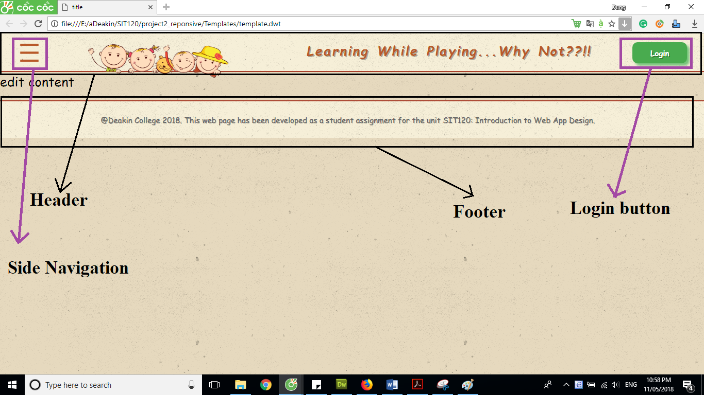The template was created first as it will be need to use throughout the website to make it consistent and clear.
  + Header: contains active button to active to side navigation, image, quote and login button
  + The active button for Side Navigation:
    - The side navigation gives more spare space for other image and quote, make webpage clear.
    - Navigation is used to link to other webpages.
  + The login button:
    - Users can login into their accounts or create a new account through this button.
  + Footer:
    - Contain the use of website (for project 2 at Deakin Colleage)

** 2 UX design patterns:

a/ The Tray: 2 main component

* + The active button
  + The tray
    - * 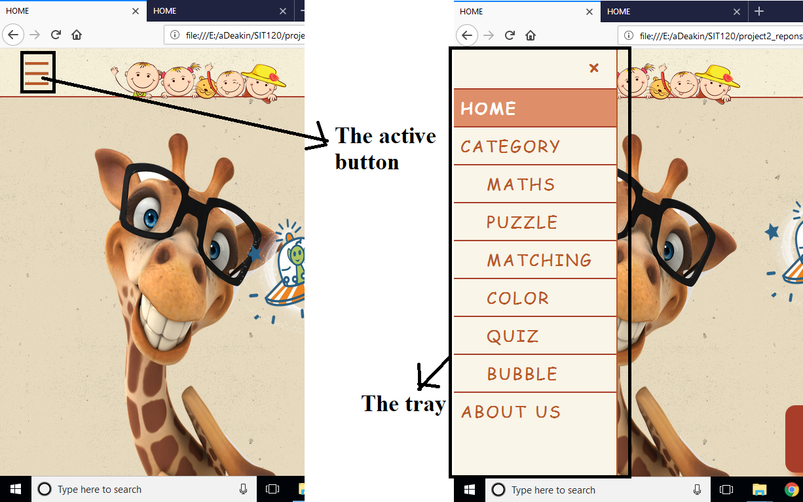Allow designers have more space without the user losing the screen what they are on

b/ The Login: 3 main components

* + The Log In
  + The Sign Up
  + The Forgot Password
    - * It is not compulsory that user have to login to play game. However, Login helps to save the score for each game; players can access from any devices and continue their games from the most recent levels

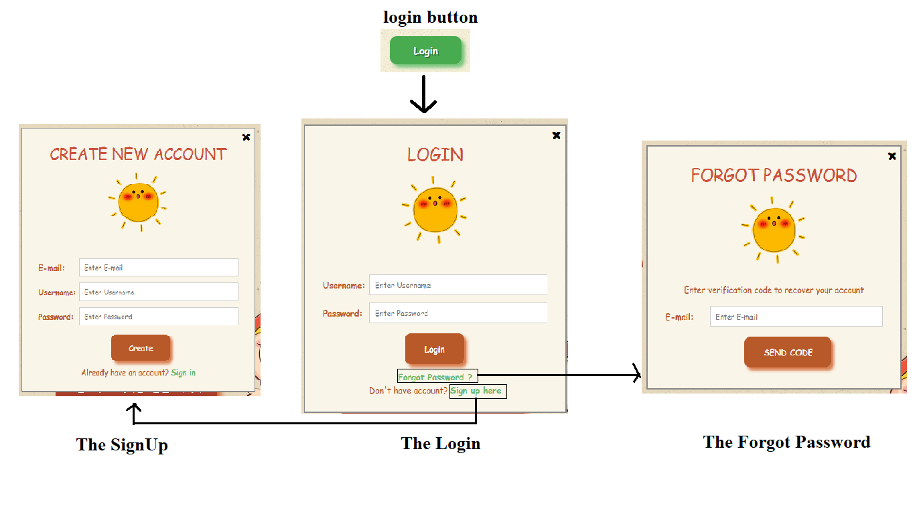*** Special element: Using JavaScript to create popup, slide up, slide down for the login pattern

1/ Home Page content:

* 2 images (giraffe and kids)
* 1 UFO with moving animation
* 1 PLAY AND LEARN button to access to Category page

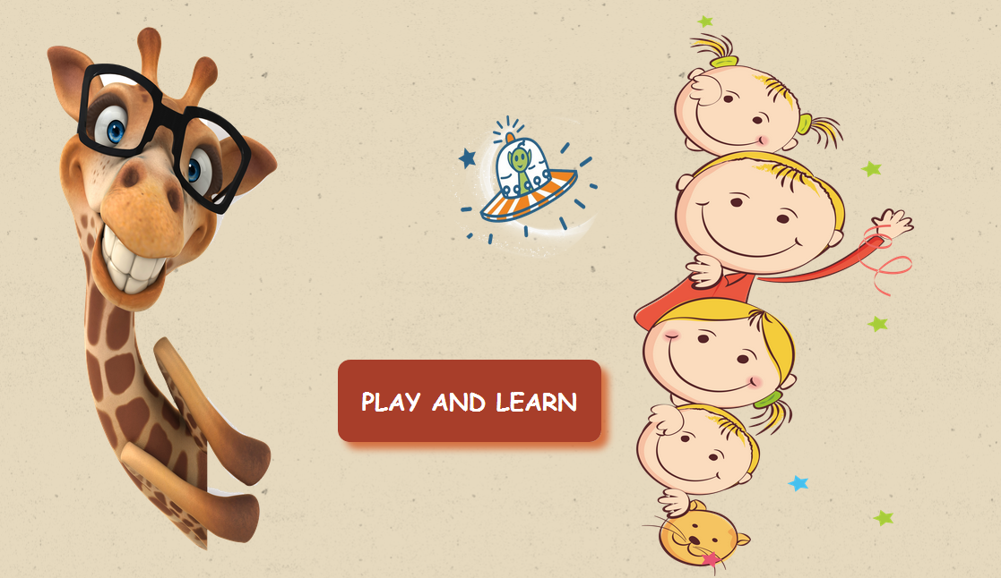

2/ Category content:

* Images and names of 6 games
* All images and names are used to access to the specific game

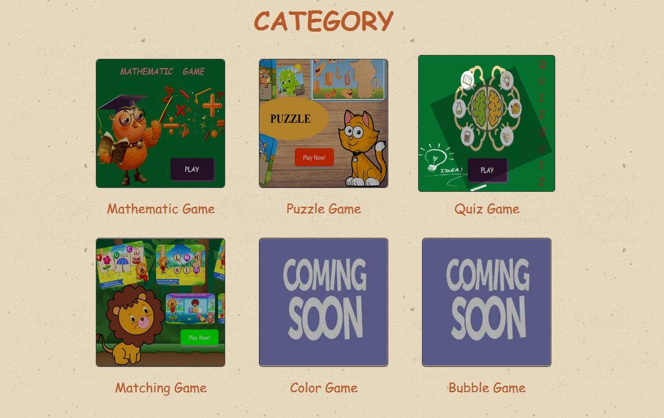*** Special elements: using transform element to make the images bigger whenever the mouse goes over

3/ Maths content:

* Name title using <h1>
* Design a box, add owl and mathematics icons image
* Using animation for name inside the box
* 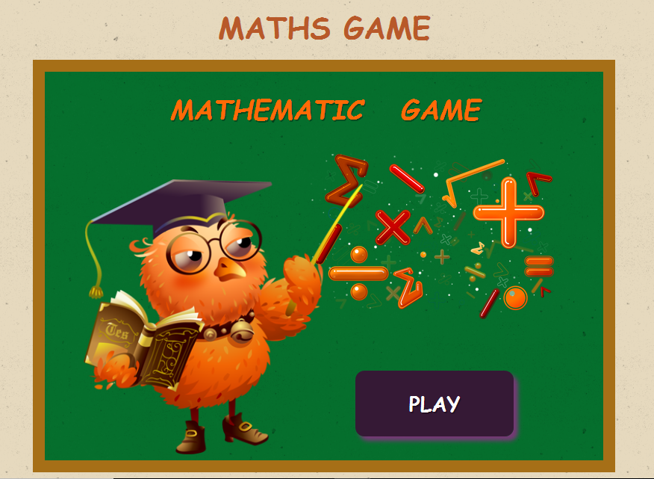PLAY button to start game

4/Color + Bubble content:

* Name title using <h1>
* Design a box with coming soon

** Using JavaScript to make count down

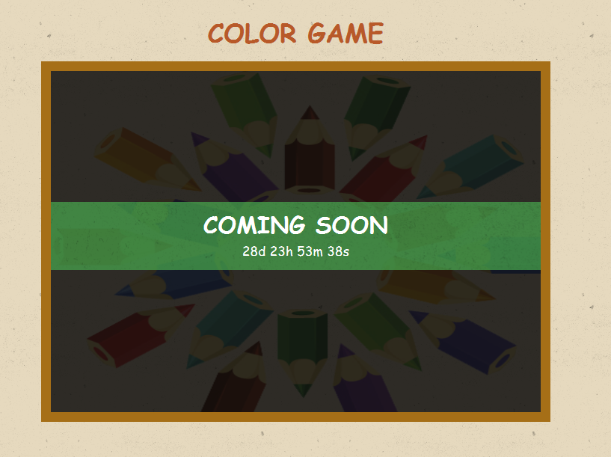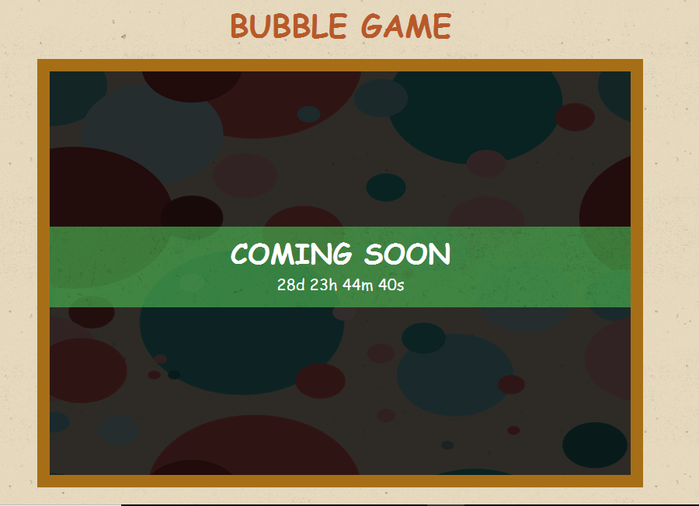

5/ Brain Workout content:

* Name title using <h1>
* Design a box, add image
* Using animation for name inside the box
* PLAY button to start game

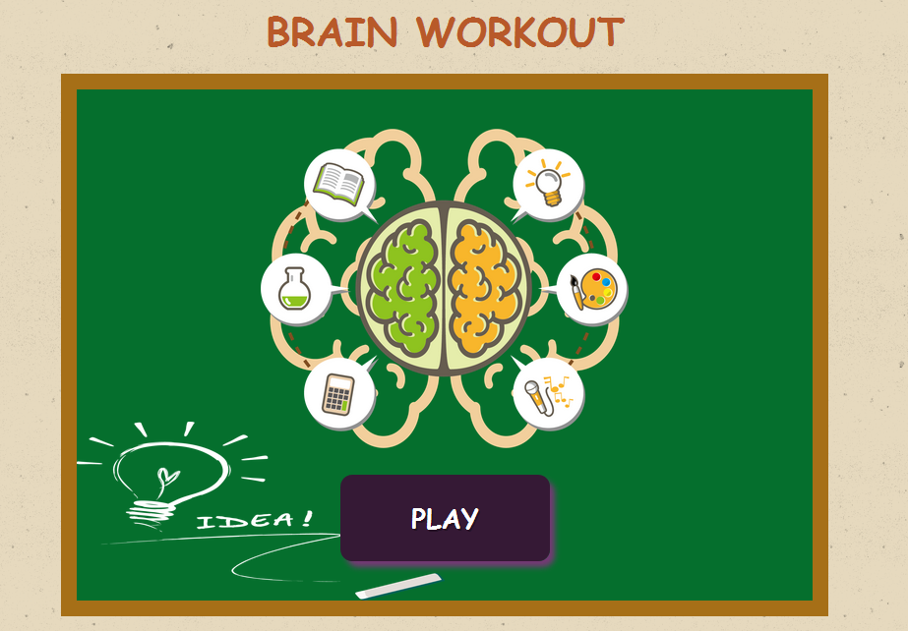

*** 7 pages above are created with font-size and images quite big so that children can easy to see and remember. All pages are designed with bright, lovely color and cute cartoon characters to make children be interested and keep using the web app.

6/ About us

* Information about Web Project

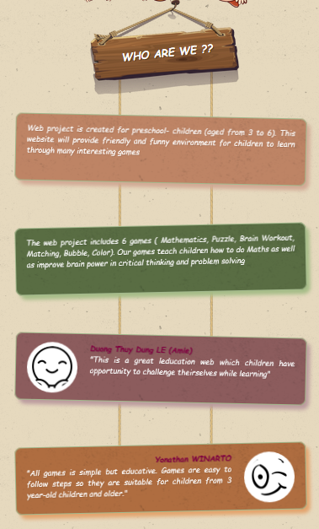

7/ Puzzle Game

The page filled with colourful animation of animals that surely attracts young kids. The word Puzzle with bold letters in the middle with flashing word also make people pay attention to the content. There is an animated ‘start’ button when user click on it.

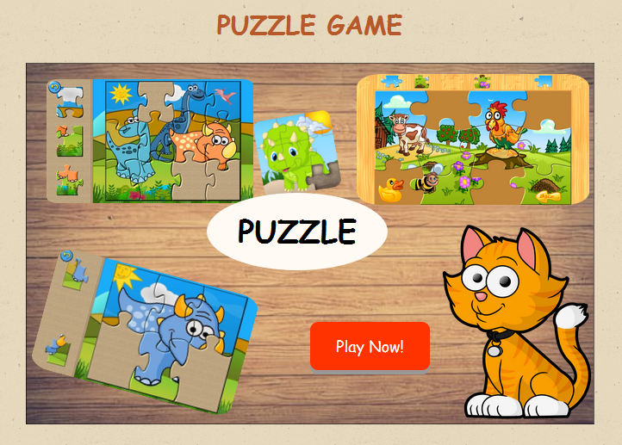

8/ Matching game page

The image is attractive. The categorisation of the games is well defined and easy to be understand by kids. There is a big ‘start’ button that is easy to access. It has “pressed” effect on click.

